EXPERIMENT NO 2: **Design a user interface prototype for a mobile station using Figma, considering connectivity and convenience.**

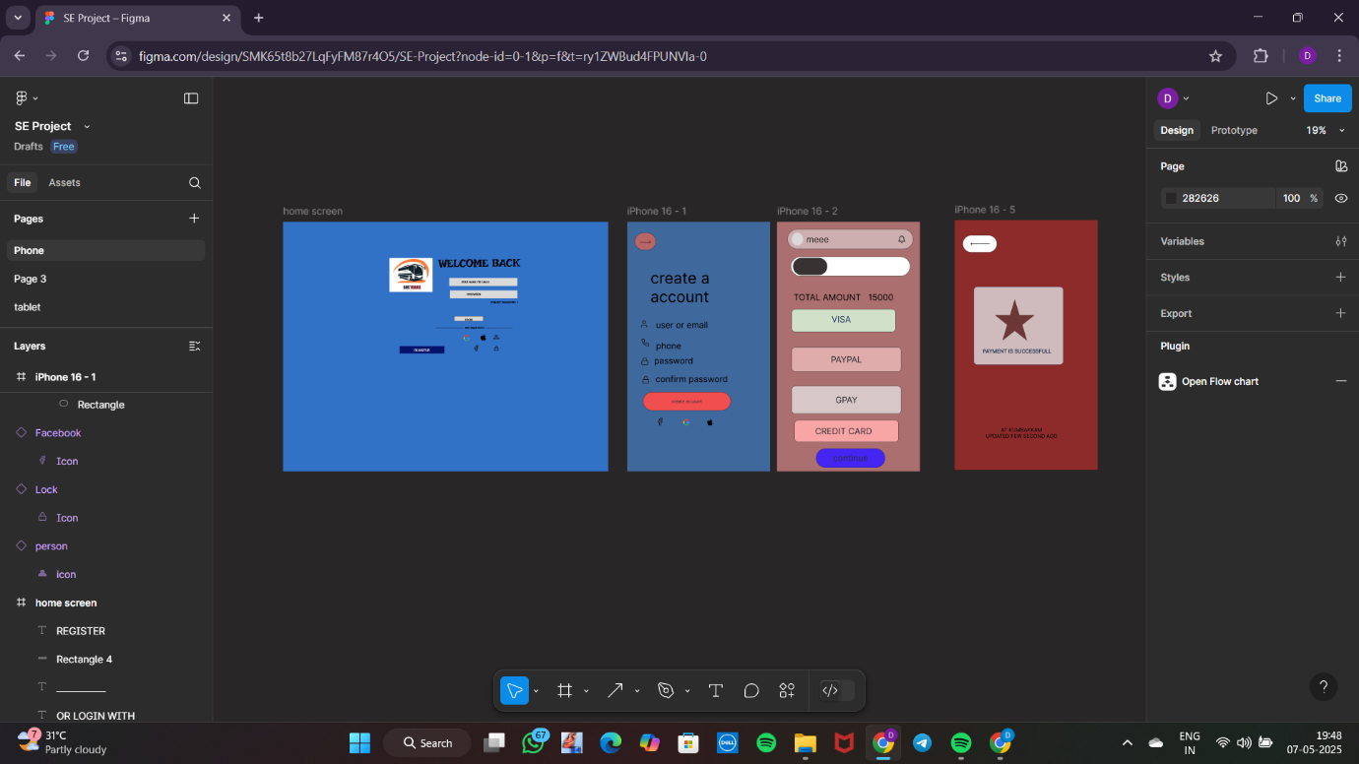

192321135 VIGNESHWAR